Charles Hesketh

Exam 4

**Problem 1**

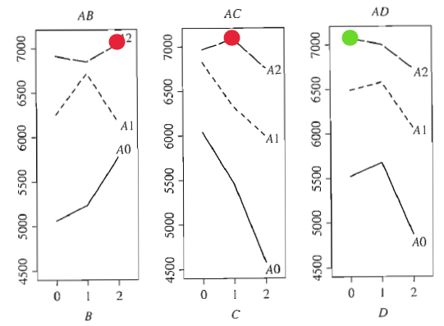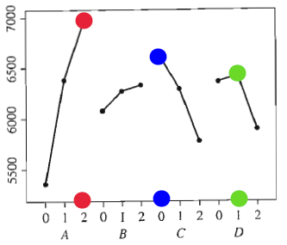 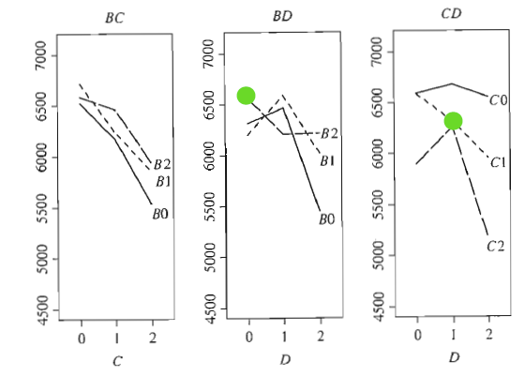

1. The graph on the right, top shows our main effects for strength location and suggests that A, C, and D are maximized at the color dots: **A=2, C=0, D=1**. Since **A x B, C x D, A x C,** and **B x D** have significance then we will look at **AB=CD2** and **AC=BD2**. In particular, the **A x B** plot suggest that **A=2** is maximized at **B=2** and **A x C** suggests **A=2** is maximized at **C=1.** Similarly, **C x D** suggest that **C=0** is maximized at **D=1**; however, after results of **A x C**, we will be choosing **C=1**, since **A** is considered to be more significant, resulting in **D=0.** We have **B x D** suggesting that **B=2** (from **A x B** plot results) is maximized when **D=0**. This suggests that **A=2, B=2, C=0**, and **D=1** (choosing **D=1** over **D=0** by MF graph) will maximize our strength location. Notice that **C=0** did not minimize **A=2** in **AB**, instead it **was C=1**, but **A** is the only factor that is significant for strength dispersion, so **A** takes priority. This yields the final result of

**<A,B,C,D>=<2,2,0,1>.**

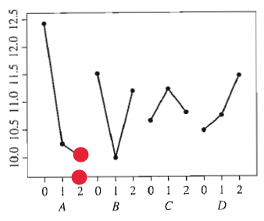

The above graph is the main effects for dispersion. As we can see this suggests that **A=2** will minimize dispersion, further suggesting our above results were selected properly. Since **A** is the only significant factor for dispersion, then we shouldn’t use it to suggest values for the other factors.

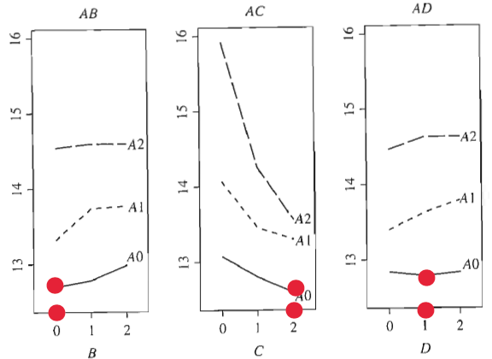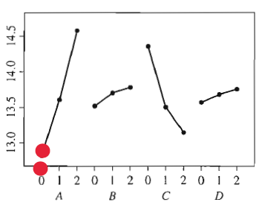

1. Only factor **A** is significant in the dispersion location which makes selecting of factors somewhat easier. From the main factor interaction, we can select **A=0**. From **A x B, A x C, A x D** we get **B=0, C=2,** and **D=1.** We aren’t concerned with **B x D** and **C x D** since **A** is the only significant factor. Thus,

**<A,B,C,D>=<0,0,2,1>.**

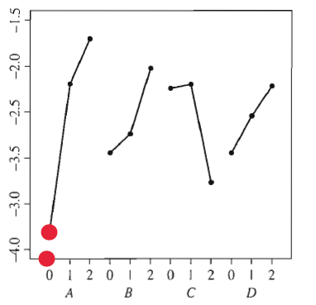

Looking at flash dispersion we see that the graph agrees in **A=0** further supporting our choices given that **A** is the only significant factor.

**Problem 2**

1. Multiplying both sides of **D=ABC** by **D2** and **E=A2BC** by **E2** we get **I=ABCD2** and **I=A2BCE2**. By convention we would like A2 to have a power of one so **(A2BCE2)2=AB2C2E=I** and this will be the alias we use. Multiplying **(ABCD2)(AB2C2E)=A2D2E** or **(A2D2E)2=ADE2** to keep convention. Furthermore we need to calculate **(ABCD2)2(AB2C2E)=BCDE**. This implies that we have **Resolution III**  and our defining contrast subgroup is

**I=ABCD2=AB2C2E=BCDE=ADE2**

1. Calculating the MF results in:

|  |  |  |  |  |  |  |  |  |
| --- | --- | --- | --- | --- | --- | --- | --- | --- |
| **Aliased:** | **I=ABCD2** | **AB2C2E** | **BCDE** | **ADE2** | **A2B2C2D** | **A2BCE2** | **B2C2D2E2** | **A2D2E** |
| **A** | AB2C2D | ABCE2 | ABCDE | AD2E | BCD2 | BCE2 | AB2C2D2E2 | **DE2** |

1. Aliased for all MF, with clear interactions highlighted:

|  |  |  |  |  |  |  |  |  |
| --- | --- | --- | --- | --- | --- | --- | --- | --- |
| **Aliased:** | **I=ABCD2** | **AB2C2E** | **BCDE** | **ADE2** | **A2B2C2D** | **A2BCE2** | **B2C2D2E2** | **A2D2E** |
| **A** | AB2C2D | ABCE2 | ABCDE | AD2E | BCD2 | BCE2 | AB2C2D2E2 | **DE2** |
| **B** | AB2CD | AC2E | BC2D2E2 | ABD2E | ACD2 | ABC2E | CDE | AB2DE2 |
| **C** | ABC2D2 | AB2E | BC2DE | ADCE2 | ABD2 | AB2CE | BDE | AC2DE2 |
| **D** | ABC | AB2C2DE | BCD2E | AD2E2 | ABCD | AB2C2D2E | BCE | **AE2** |
| **E** | ABCD2E | AB2C2E2 | BCDE2 | **AD** | ABCD2E2 | AB2C2 | BCD | ADE |

Aliased for all 2-fis, with clear interactions highlighted:

|  |  |  |  |  |  |  |  |  |
| --- | --- | --- | --- | --- | --- | --- | --- | --- |
| **Aliased:** | **I=ABCD2** | **I=AB2C2E** | **I=BCDE** | **I=ADE2** | **I=A2B2C2D** | **I=A2BCE2** | **I=B2C2D2E2** | **I=A2D2E** |
| **AB** | ABC2D | ACE2 | AB2CDE | AB2D2E | **CD2** | BC2E | AC2D2E2 | BD2E |
| **AC** | AB2CD | ABE2 | ABC2DE | AC2D2E | **BD2** | BC2E2 | AB2D2E2 | CD2E |
| **AD** | AB2C2 | ABCD2E2 | ABCD2E | ADE | BCD | BCDE2 | AB2C2E2 | **E** |
| **AE** | AB2C2DE2 | ABCE | ABCDE2 | **AD2** | BCD2E2 | **BC** | AB2C2D2 | **DE** |
| **BC** | AB2C2D2 | **AE** | BCD2E2 | ABCDE2 | **AD2** | ABCE | **DE** | AB2C2DE2 |
| **BD** | AB2C | AC2DE | BC2DE2 | ABD2E2 | ACD | ABC2D2E | **CE** | AB2E2 |
| **BE** | AB2CE | AC2E2 | BC2D2E | ABD | ACD2E2 | ABC2 | **CD** | AB2DE |
| **CD** | ABC | AB2DE | BC2D2E | ACD2E2 | ABD | AB2CD2E | **BE** | AC2E2 |
| **CE** | ABCD2E | AB2E | BC2DE2 | ACD | ABD2E2 | AB2C | **BD** | AC2DE |
| **DE** | ABCE | AB2C2DE2 | BCD2E2 | **AD** | ABCDE2 | AB2CD | **BC** | **AE** |
|  |  |  |  |  |  |  |  |  |
| **AB2** | AC2D | AB2CE2 | ACDE | ABD2E | BC2D | **CE2** | ABC2D2E2 | BDE2 |
| **AC2** | AB2D | ABC2E2 | ABDE | ACD2E | BC2D2 | **BE2** | AB2CD2E2 | CDE2 |
| **AD2** | AB2C2D2 | ABCDE2 | ABCE | **AE** | **BC** | BCD2E2 | AB2C2DE2 | **DE** |
| **AE2** | AB2C2DE | ABC | ABCD | ADE2 | BCD2E | BCE | AB2C2D2E | **D** |
| **BC2** | AB2D2 | ACE | BD2E2 | ABC2DE2 | AC2D2 | ABE | CD2E2 | AB2CDE2 |
| **BD2** | AB2CD | AD2C2E | BC2E2 | ABE2 | **AC** | ABC2DE | CD2E | AB2D2E2 |
| **BE2** | AB2CD2E2 | **AC2** | BC2D2 | ABDE | ACD2E | ABC2E2 | CDE2 | AB2D |
| **CD2** | ABC2D | AB2D2E | BC2E | ACDE | **AB** | AB2CDE | BD2E | AC2D2E2 |
| **CE2** | ABC2D2E2 | **AB2** | BC2D | ACDE | ABD2E | AB2CE2 | BDE2 | AC2D |
| **DE2** | ABCE2 | AB2C2DE2 | BCD2 | AD2E | ABCDE | AB2C2D2E2 | BCE2 | **A** |

1. The only MF or 2-fis that are clear are B, C, and BC2 as all other 2-fis are aliased with another 2-fi or MF. All other MF are aliased with at least one 2-fi.

|  |  |  |  |  |  |  |  |  |
| --- | --- | --- | --- | --- | --- | --- | --- | --- |
| **Aliased:** | **I=ABCD2** | **I=AB2C2E** | **I=BCDE** | **I=ADE2** | **I=A2B2C2D** | **I=A2BCE2** | **I=B2C2D2E2** | **I=A2D2E** |
| **B** | AB2CD | AC2E | BC2D2E2 | ABD2E | ACD2 | ABC2E | CDE | AB2DE2 |
| **C** | ABC2D2 | AB2E | BC2DE | ADCE2 | ABD2 | AB2CE | BDE | AC2DE2 |
| **BC2** | AB2D2 | ACE | BD2E2 | ABC2DE2 | AC2D2 | ABE | CD2E2 | AB2CDE2 |

Even though **BC2** is clear, since **BC** is not clear then **B x C** is not clear. This implies **A x B, A x C, A x D, A x E, B x C, B x D, B x E, C x D, C x E, D x E** are all not clear since both their components are not clear.